Dean Schulz – Class Time

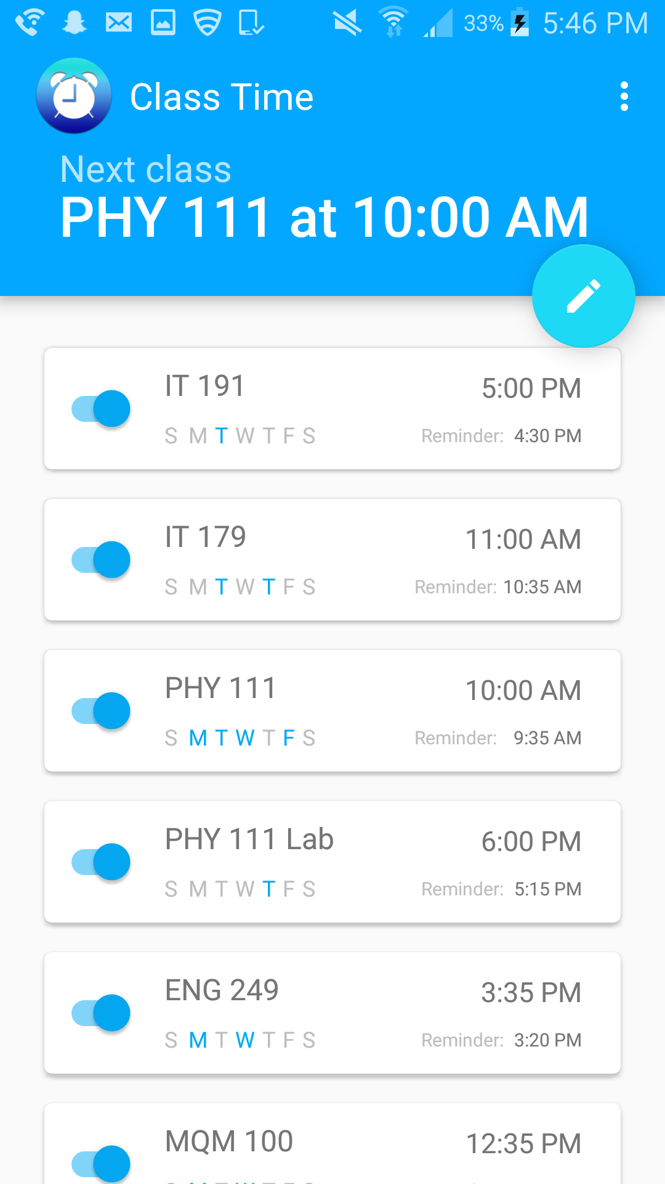

Description: This is the main page which stores your classes.

Delete: swipe left or right (found in Reminders class)

Toggle: enable or disable the notification (found in ReminderAdapter class)

FAB and cardview: add or update class (found in NotificationDialog class)

Button on top right: settings menu (found in MenuFragment class)

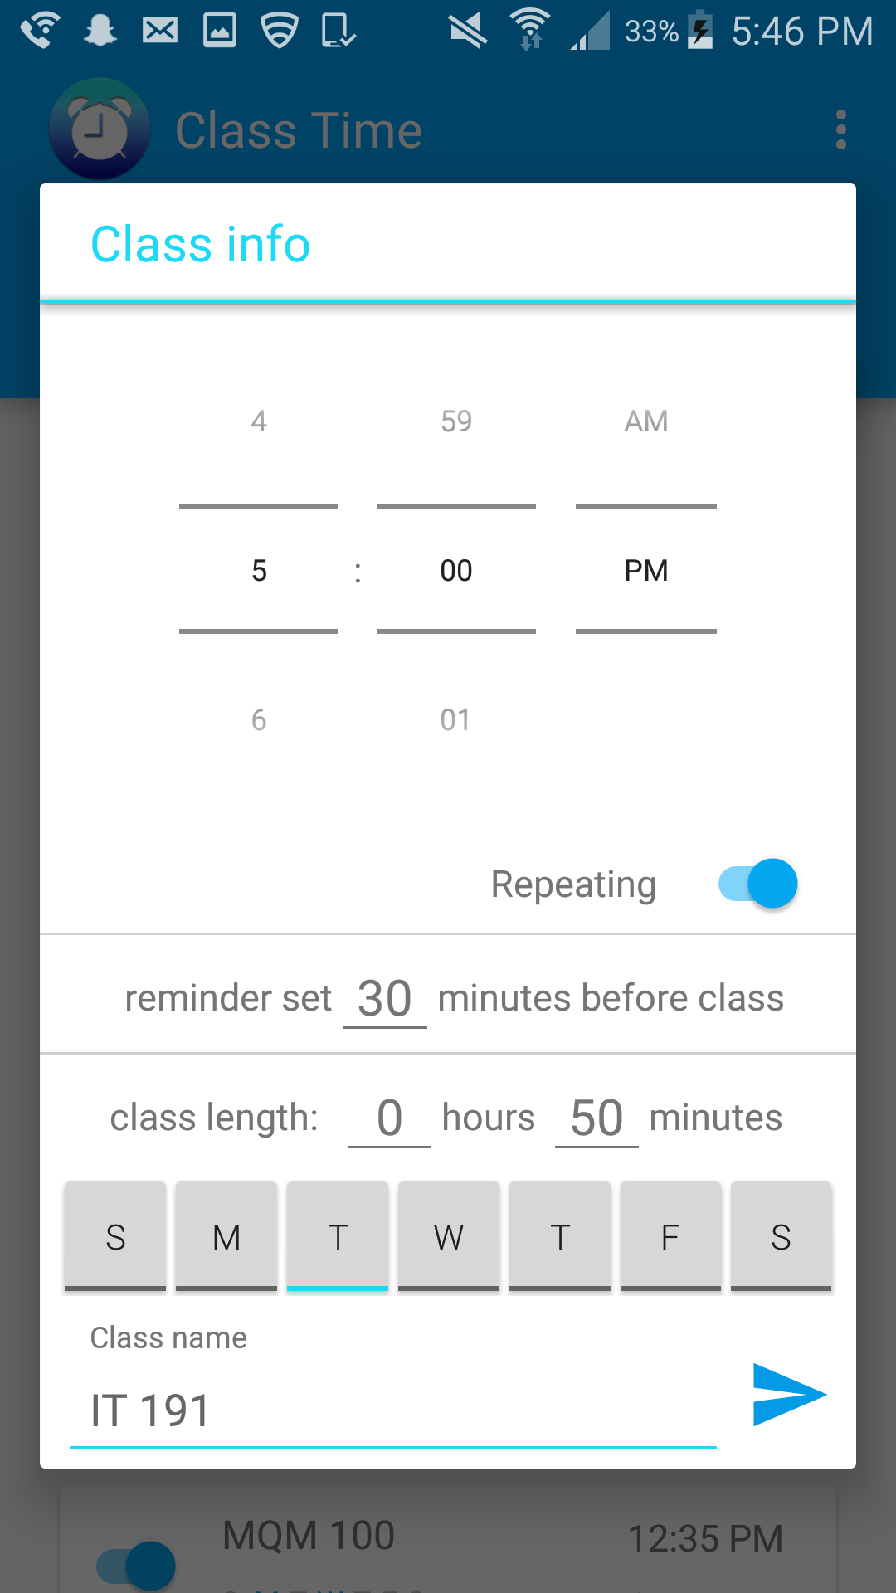

Description: This page adds or updates a class in the list.

(found in NotificationDialog class)

Repeating toggle: enable or disable weekly reminders

Input all class information

Description: this is the settings menu.

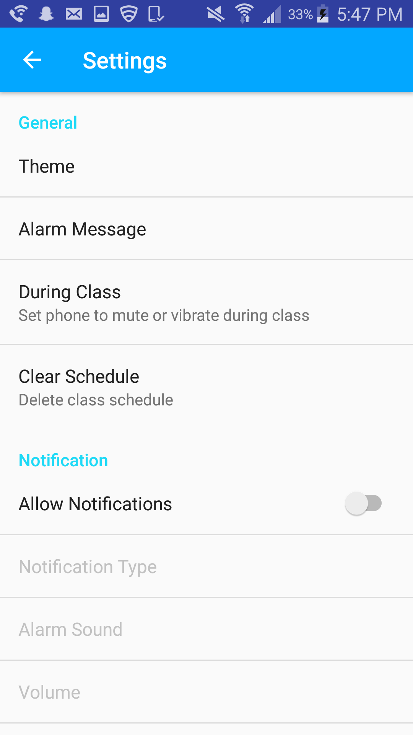

(found in MenuFragment class)

Here you can: set the theme, alarm message, set your phone to mute or vibrate during classes, delete all classes, enable or disable all notifications, set the type of notification, choose the alarm sound, and set the volume of the alarm sound.

(SetVolume class also used)

3. Developer manual:

- developed using Android Studio

- Application classes

Activities

**MainActivity** – This is the main activity that gets created when the app is run. It creates the onClickListeners for all of the main screen buttons.

**PreferenceVariables** – This class is used to get volume from the settings menu.

**PreferenceVars** – This class is used to get the notification type, what happens during class, and the theme color.

**TextViews** – This class sets the next class that is displayed on the main activity page.

Adapters

**ReminderAdapter** – This class contains and manipulates the list of class reminders. Also sets the time and day of the week colors on each cardview.

Alarm

**AlarmMute** – This class is an alarm receiver that fires when the class starts and sets the phone to mute or vibrate depending on the settings choice.

**AlarmReceiver** – this class is an alarm receiver that fires at the time that the user needs to be reminded to head to class.

**AlarmSound** – This class is an alarm receiver that fires when the alarm sound needs to be played.

**DeviceBootReceiver** - This class is an alarm receiver that fires when the phone turns back on to retrieve the data.

**MuteOff** - This class is an alarm receiver that fires when the class is over and the phone is set to the original volume.

Fragments

**MenuFragment** – This class contains the preference listeners for the custom settings.

**NotificationDialog** – This class runs the adding a class notification dialog. Send button calls the create or update method in ReminderManager.

**Reminders** – This class contains the touch helper that detects when one of the cardviews is touched.

**SetVolume** – This class runs the volume dialog and sets the volume.

managers

**RealmManager** – This class is used to get the realm which contains the data to each class.

**ReminderManager** – This class contains most of the calculations and methods that are run in the background. The major methods that are used here are the create, update, cancel alarm, and get next class methods.

models

**Reminder** – This class contains the information for each reminder such as the name, time, days of week, etc.